A

RESEARCH PROJECT REPORT

ON

“A STUDY ON MOBILE APPLICATIONS IN PERSONAL FINANCE MANAGEMENT”

IN PARTIAL FULFILLMENT OF

MASTER OF COMPUTER APPLICATION

BY

JAYSHRI BHASKAR KOR

MCA –II, SEM – III (2025-2026)

UNDER THE GUIDANCE OF
PROF. Dr. URMILA KADAM
SUBMITTED TO


SAVITRIBAI PHULE PUNE UNIVERSITY

Dr. D Y PATIL SCHOOL OF MCA, Charoli (BK.), Pune  Date:

CERTIFICATE

This is to certify that Ms. JAYSHRI BHASKAR KOR , has successfully completed
her research project work entitled “A STUDY ON MOBILE APPLICATIONS IN
PERSONAL FINANCE MANAGEMENT” in partial fulfilment of MCA – II, SEM –III RP31 Research Project for the year 2025-2026. She has worked under our guidance and direction.

Prof. Dr. Urmila Kadam Prof. Sapna Chavan Dr. E. B. Khedkar
Project Guide HOD Director

Date:
Place:

AKCNOWLEDGMENT

I acknowledge to all those who have been so helpful in my academic project work. Nevertheless, I have made an effort through this report to express my deepest gratitude to all those who have given their precious time, skill, knowledge, valuable advice and guidance and facilities.

At the very outset I take opportunity to express my deepest gratitude and thanks to Director of our College Dr. E. B. Khedkar and Prof. Sapna Chavan-HOD and other teaching and non-teaching staff for their useful guidance during the completion of this project Report.

I am highly obliged to Prof. Dr. Urmila Kadam Project Guide for her valuable guidance and encouragement given to complete the project. Her guidance has certainly helped me to simplify the difficulties and finalize the system effectively. Last but not the least I thank to my almighty God, Parents and friends for their constant support to me in all aspects during the course of work.

Thank You,

Ms. Jayshri Bhaskar Kor

MCA-II (Sem-III)
Dr. D. Y. Patil School of MCA, Charholi(BK.), Pune

Index: Research-Based Project

Chapter | Content | Page Number
Chapter 1 | Introduction | 6 – 9
1.1 | Research Problem | 8
1.2 | Objectives | 9
Chapter 2 | Literature Review | 11 – 14
2.1 | Existing Research | 11
2.2 | Research Gaps | 13
Chapter 3 | Methodology | 15 – 18
3.1 | Research Design | 16
3.2 | Data Collection | 16
3.3 | Analysis Methods | 18
Chapter 4 | Results and Discussion | 19 – 27
4.1 | Findings | 20
4.2 | Implications | 26
Chapter 5 | Conclusion | 28 – 31
5.1 | Summary | 29
5.2 | Future Work | 30
Chapter 6 | References | 32 – 34
Chapter 7 | Appendices | 35 – 53
Chapter 8 | Annexure -Progress Sheet | 54 – 55

Index : List of Figures & Tables
Sr. No. | Figure No. | Name | Page No.
1 | Fig.4.1 | Age Distribution of Respondents | 20
2 | Fig.4.2 | Occupation-wise Distribution of Respondents | 21
3 | Fig.4.3 | Most Frequently Used Mobile Finance Applications | 21
4 | Fig.4.4 | Frequency of App Usage among Respondents | 22
5 | Fig..4.5 | Impact of Mobile Finance Applications on Expense Tracking and Savings | 22
6 | Fig.4.6 | Influence of Mobile Finance Apps on Investment Decisions | 23
7 | Fig.1 | Respondents using finance apps | 43
8 | Fig.2 | Gender Distribution of Respondents | 43
9 | Fig.3 | Age Distribution of Respondents | 44
10 | Fig.4 | Occupation-wise Distribution of Respondents | 44
11 | Fig.5 | Monthly Income Range | 45
12 | Fig.6 | Most Used Mobile Finance Apps | 45
13 | Fig.7 | Education Level of Respondents | 46
14 | Fig.8 | Frequency of App Usage | 46
15 | Fig.9 | Impact on Expense Tracking | 47
16 | Fig.10 | Impact on Investment Decisions | 47
17 | Fig.11 | Impact on Savings | 48
18 | Fig.12 | Influence of Mobile Finance Apps on Investment Decisions | 48
19 | Fig.13 | Financial Advice from Apps | 49
20 | Fig.14 | Usefulness of Financial Advice | 49
21 | Fig.15 | Hypothesis Testing Result | 52
22 | Fig.16 | Chi-Square value and p-value Result | 53
23 | Table 1 | Results of Chi- Square tests | 24
24 | Table 2 | Results of Chi-Square Tests | 52

CHAPTER 1 – INTRODUCTION

1. Introduction
Effective personal finance management is essential for financial stability, and mobile finance applications have revolutionized the way individuals track expenses, budget, save, and invest. Traditional methods like manual bookkeeping have been replaced by AI-driven financial tools that offer real-time insights and automation. With the increasing adoption of fintech solutions, these applications provide convenience and accessibility, but concerns remain regarding security risks, AI accuracy, and financial literacy improvement. This study explores the impact, benefits, and challenges of mobile finance applications in personal finance management. The collected data was analysed using Python to perform statistical testing and visualization for better accuracy in results.

Background
In the digital age, personal finance management has become more accessible and efficient due to the rise of mobile finance applications. These applications offer users advanced tools to monitor expenses, create budgets, automate savings, and invest in financial markets. With the integration of Artificial Intelligence (AI) and Machine Learning (ML), mobile finance apps now provide personalized financial recommendations, predictive analytics, and automated financial planning. Applications such as Mint, YNAB (You Need a Budget), PocketGuard, and Acorns have transformed how individuals manage their finances by offering real-time insights and structured financial guidance.
The COVID-19 pandemic further accelerated the adoption of mobile finance applications as people shifted to digital banking and cashless transactions due to lockdowns and social distancing measures. Many individuals and businesses turned to mobile budgeting and investment apps to track their finances, manage income fluctuations, and optimize spending during economic uncertainty.
This rapid shift marks a significant transition from traditional financial management methods—such as manual bookkeeping and spreadsheets—to digital solutions that offer automation, convenience, and data-driven insights. As financial technology (fintech) continues to grow, mobile finance applications have emerged as powerful tools for enhancing financial literacy, improving budgeting habits, and fostering disciplined spending behaviours in a post-pandemic world.

Significance of the Study
Understanding the role of mobile finance applications in personal finance management is crucial for financial institutions, fintech developers, and policymakers aiming to promote financial inclusion and responsible money management. This study provides insights into how developers can enhance mobile finance applications by improving financial education tools, budgeting features, and overall user engagement. Additionally, this research emphasizes the importance of financial literacy programs that complement digital financial tools. By bridging the gap between technology and financial knowledge, mobile finance applications can be optimized to offer more effective financial solutions for users.

Scope of the Study
This This study focuses on individuals who use mobile finance applications for budgeting, saving, investing, expense tracking, and digital transactions. It examines the impact of these applications on financial literacy, budgeting habits, and overall financial well-being. The research considers both advantages and challenges of mobile finance apps, including privacy concerns, usability issues, and reliance on AI-driven financial recommendations. Popular applications such as Google Pay, PhonePe, Paytm, Mint, YNAB (You Need a Budget), PocketGuard, and Acorns are analyzed to understand their role in personal finance management and digital payments.

  - Research Problem
In today’s digital world, managing personal finances has become more complex due to multiple income sources, online transactions, and changing financial habits. Traditional methods such as manual bookkeeping or spreadsheet tracking are time-consuming and often lead to errors.
With the rapid growth of financial technology (FinTech), mobile applications have become a convenient and accessible solution for personal finance management. These apps allow users to track expenses, set budgets, save money, and make financial decisions using real-time insights and AI-driven recommendations.
However, despite their popularity, many users are not fully aware of how effectively these apps influence their financial habits. Concerns related to data privacy, over-reliance on automation, and low financial literacy still limit their potential benefits. Hence, there is a growing need to study how mobile finance applications impact users’ budgeting behavior, saving habits, and financial literacy — especially in the Indian context, where digital transactions are increasing rapidly.

  - Objectives of the Study
1. To examine how mobile finance applications influence budgeting, saving, and investment habits.
2. To identify challenges users face, such as security concerns and the over-reliance on automation.
3. To evaluate the effectiveness of AI-driven financial recommendations in personal finance management.
4. To suggest improvements for making mobile finance applications more secure, user-friendly, and effective for financial decision-making.

CHAPTER 2 – LITERATURE REVIEW

2.Literature Review
Mobile finance applications have transformed financial management by providing users with tools for budgeting, saving, tracking expenses, and investing. While these applications enhance financial planning, they also present challenges such as security risks, over-reliance on automation, and inaccuracies in AI-driven recommendations.This chapter reviews existing research on their evolution, benefits, challenges, and theoretical foundations.
  - Existing Research
1.Deloitte (2022) reported that more than 60% of smartphone users rely on at least one mobile finance application for budgeting or expense tracking, showing how these apps have become a core part of modern money management.
2. Kapoor & Singh (2020) emphasized that earlier, individuals used manual bookkeeping and Excel sheets to track finances, which required time and effort. Fintech apps like Mint and YNAB now automate these tasks using AI algorithms that analyze spending patterns and give personalized insights.
3. Brown et al. (2021) highlighted that the integration of AI and Machine Learning (ML) allows mobile finance apps to deliver real-time predictive analytics, enabling users to make better budgeting and saving decisions.
4. Kapoor & Singh (2021) found that structured financial dashboards in budgeting apps reduce unnecessary spending by 20–30% through the use of alerts and visual summaries.
5. Johnson et al. (2019) discovered that regular use of mobile finance applications strengthens financial discipline, improves savings behavior, and helps users achieve long-term financial goals.
6. Brown & Peterson (2020) examined savings-focused apps such as Acorns and Qapital, which use micro-saving and round-off techniques to encourage consistent savings growth with minimal user effort.
7. Lee & Kim (2022) concluded that mobile investment applications like Robinhood and Wealthfront have democratized investing by reducing entry barriers for individuals without professional financial training.
8. Johnson et al. (2019) found that apps that include credit-score tracking and educational modules empower users to make more informed borrowing and repayment decisions.
9. Smith & Waller (2021) stated that access to educational content in finance apps promotes financial literacy, leading to improved debt management and spending control.
10. Gartner (2023) revealed that 38% of users hesitate to link their bank accounts with finance apps due to privacy and security concerns, emphasizing the importance of cybersecurity in fintech design.
11. Deloitte (2022) confirmed that although two-factor authentication and encryption are widely used, user trust remains a challenge because of increasing cyber threats and data leaks.
12. Smith & Waller (2022) warned that excessive reliance on AI-based recommendations can create over-dependence, reducing users’ financial awareness and critical decision-making abilities.
13. Lee et al. (2021) stated that users who depend too much on automation often face difficulties during unexpected financial events that require human judgment.
14. Lee et al. (2021) also reported that while 75% of users consider AI advice helpful, about 30% encountered inaccurate suggestions, showing the need for improved algorithmic accuracy.
15. Brown et al. (2020) pointed out that AI-generated financial recommendations are often generic and fail to account for personalized goals and risk preferences, limiting their effectiveness.
16. Financial Literacy Theory (2020) explains that individuals with greater financial knowledge make more rational economic decisions. This theory supports integrating learning modules within fintech apps to enhance financial capability.
17. Sharma & Gupta (2021) studied Indian users and found that apps like PhonePe and Paytm are preferred because of local language interfaces, reward systems, and ease of digital payments.
18. KPMG (2022) reported that fintech app usage in India grew by 120% after the COVID-19 pandemic as users shifted toward cashless transactions and online budgeting tools.
19. Mehta & Roy (2020) found that young adults aged 20–30 form the largest segment of mobile finance app users due to convenience, smartphone availability, and digital payment familiarity.
20. PwC (2022) observed that global fintech adoption has reached 73%, demonstrating a worldwide shift toward mobile-based financial management solutions.
21. Joshi et al. (2021) highlighted that app-based expense tracking improves users’ financial confidence and reduces stress by providing better visibility into spending patterns.
22. Accenture (2021) stated that integrating AI-based chatbots and virtual assistants in mobile finance apps enhances customer support and engagement, offering real-time financial guidance.
23. Patel & Deshmukh (2020) found that lack of digital and financial literacy is still a major obstacle for Indian users, especially in rural regions, affecting the full adoption of mobile finance apps.
24. EY Global FinTech Report (2023) noted that 64% of consumers in developing economies believe that mobile finance apps help them control spending and achieve better budgeting outcomes.
25. Narayan & Iyer (2021) concluded that combining financial education with digital financial tools strengthens long-term saving habits and promotes responsible financial behavior.
Collectively, these studies confirm that mobile finance applications have improved accessibility and control over personal finances while raising new challenges related to data security, AI reliability, and financial awareness.

2.2 Research Gaps
Despite the growing body of research on mobile finance applications, several gaps remain that require deeper investigation:
- Very few studies explore how mobile finance applications impact financial literacy and awareness among Indian users.
- Most existing research focuses on technical features rather than the behavioral outcomes of app usage.
- There is limited examination of how AI-based financial recommendations affect users’ independent decision-making skills.
- Many studies emphasize Western markets, with minimal focus on the Indian fintech ecosystem and its cultural aspects.
- Only a few researchers have used Python-based data analytics for empirical evaluation of user responses.
- Security concerns and data-privacy issues specific to Indian users remain under-researched.
- Post-pandemic studies are scarce in analyzing how COVID-19 influenced long-term digital finance adoption.
- Few works address how financial apps can incorporate educational content to bridge the financial literacy gap.
- Research rarely compares different categories of apps (budgeting, investing, saving) to understand which are most effective.
- There is a lack of holistic frameworks combining AI reliability, data security, and user satisfaction.
To bridge these gaps, the present study evaluates how mobile finance applications influence budgeting habits, saving behavior, and financial literacy using Python-based quantitative analysis. It also highlights potential improvements for fintech developers to make these apps more secure, personalized, and educational.

CHAPTER 3 – METHODOLOGY

3. Methodology
This chapter presents the research methodology adopted for the study titled “A Study on Mobile Applications in Personal Finance Management.” It explains the research design, data collection procedure, and analysis methods used to examine how mobile finance applications influence users’ budgeting, saving, and investment habits, as well as their overall financial literacy.
The research follows a deductive approach, beginning with a theoretical understanding of mobile finance applications and testing hypotheses using empirical data from respondents.
3.1 Research Design
The present study adopted a quantitative and descriptive research design to obtain measurable insights into user behavior and perceptions regarding mobile finance applications. The research aimed to analyze patterns, relationships, and impacts using statistical methods to ensure accuracy and objectivity.
A structured questionnaire survey was used as the primary tool for data collection. The study design was formulated to evaluate how various factors—such as usage frequency, app features, and user demographics—affect financial decision-making.
This design was chosen because it enables systematic collection of numerical data and allows for both descriptive and inferential statistical analysis. The results were then used to identify behavioral trends, assess the effectiveness of financial applications, and test the stated hypotheses through statistical validation.
3.2 Data Collection
The study utilized primary data, collected through an online Google Form survey distributed among users of mobile finance applications. A total of 124 valid responses were obtained from respondents belonging to diverse backgrounds including students, working professionals, and self-employed individuals.
The questionnaire was carefully structured into three main sections:
- Demographics: Age, gender, occupation, education level, and monthly income.
- Usage Behavior: Types of finance applications used (Google Pay, PhonePe, Paytm, etc.), frequency of use, and primary purposes (payments, budgeting, savings, or investment).
- Impact Measures: Users’ opinions regarding expense tracking, savings behavior, financial literacy, investment awareness, trust, and data security.
The collected responses were exported in CSV format for data analysis. In addition to primary data, secondary data was gathered from journals, research papers, and industry reports (e.g., Deloitte, Gartner, and PwC) to support the findings and establish comparisons with existing studies.
The study adopted a convenience sampling technique, where participants were selected based on their availability and active use of mobile finance applications. The sample included both male and the female users aged between 18 and 45 years from different educational and occupational backgrounds.

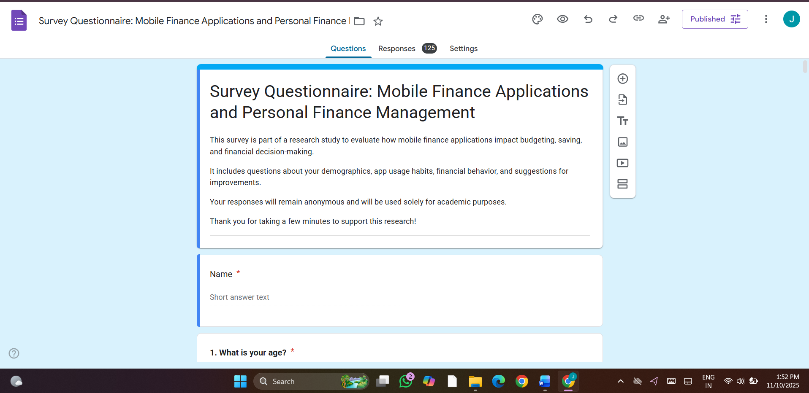
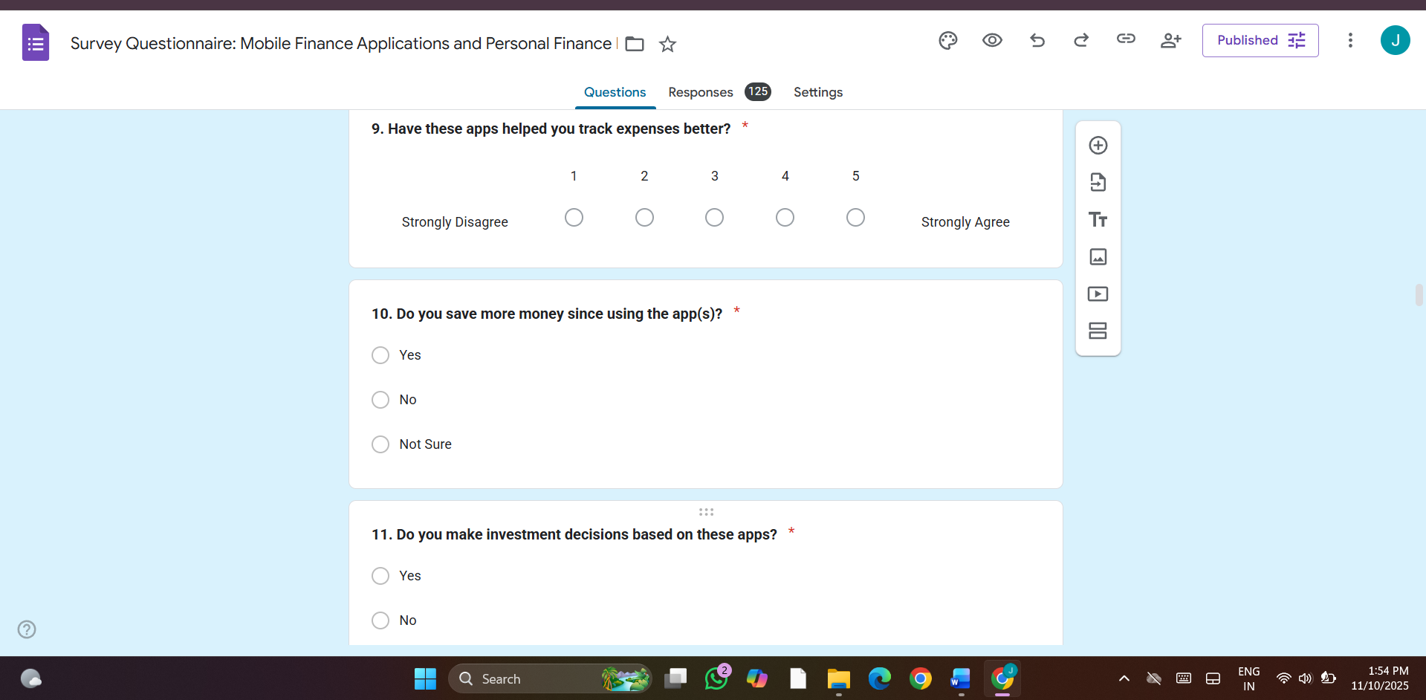
3.3 Analysis Methods
The collected data was analyzed using the Python programming language, employing libraries such as pandas, matplotlib, seaborn, and scipy for statistical analysis and visualization.
- Descriptive Statistics (frequencies and percentages) were used to summarize demographic information and app usage patterns.
- Graphical Analysis was performed using bar charts, histograms, and pie charts to visually interpret responses and highlight key trends.
- Inferential Statistics were applied through Chi-square tests of independence to determine relationships between key variables, such as:
  - Expense tracking and savings behavior.
  - Financial advice and financial literacy improvement.
A significance level of 0.05 (p < 0.05) was used to identify statistically meaningful relationships. The use of Python ensured accuracy, transparency, and reproducibility in the data analysis process.
The results of the analysis indicated that mobile finance applications have a significant impact on improving financial literacy, a moderate effect on budgeting, and a limited influence on investment decisions. These findings provided a comprehensive understanding of user behavior and validated the research hypotheses.

Hypothesis of the Study
Based on the objectives and research problem, the following hypotheses were formulated to test the relationship between mobile finance application usage and users’ financial behavior:
H₀ (Null Hypothesis):
Mobile finance applications do not significantly improve financial literacy, budgeting habits, or investment decisions of users.
H₁ (Alternative Hypothesis):
Mobile finance applications significantly enhance financial literacy, budgeting habits, and investment decisions of users.

CHAPTER 4 –
RESULTS AND DISCUSSION

4. Results and Discussion
This chapter presents the results of the data analysis and discusses the key findings of the study. It explains how mobile finance applications influence users’ budgeting habits, savings behavior, financial literacy, and investment decisions. The results were derived from the analysis of 124 survey responses, which were processed and visualized using Python libraries for statistical accuracy and clarity.
Visualizations such as bar charts, histograms, and pie charts were used to represent the responses clearly and accurately.

4.1 Findings
1. Demographic Profile of Respondents
The survey included 124 valid responses collected through a Google Form.
As shown in Figure 4.1, the majority of respondents belonged to the age group of 18–35 years, indicating that mobile finance applications are predominantly used by young and tech-savvy individuals.
Most participants were either students or working professionals, as represented in Figure 4.2.
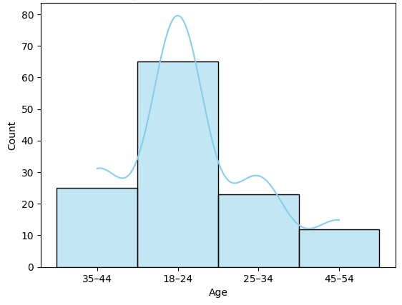
Figure 4.1: Age Distribution of Respondents
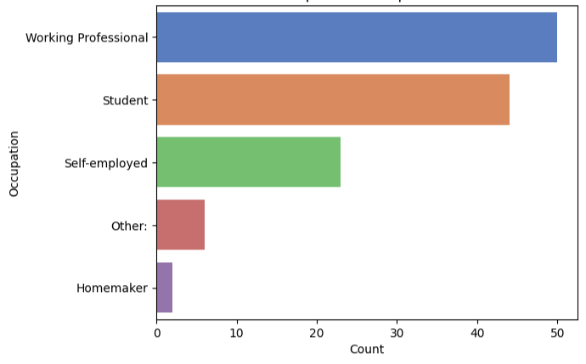
Figure 4.2: Occupation-wise Distribution of Respondents
This demographic pattern highlights that mobile finance apps are most popular among digitally literate youth who prefer convenience, automation, and mobile access in managing their finances.

2. Usage Behavior of Mobile Finance Applications
Respondents reported using a variety of mobile finance apps such as Google Pay, PhonePe, Paytm, Mint and YNAB. As illustrated in Figure 4.3, Google Pay and PhonePe were found to be the most commonly used applications for day-to-day financial transactions, followed by Paytm.
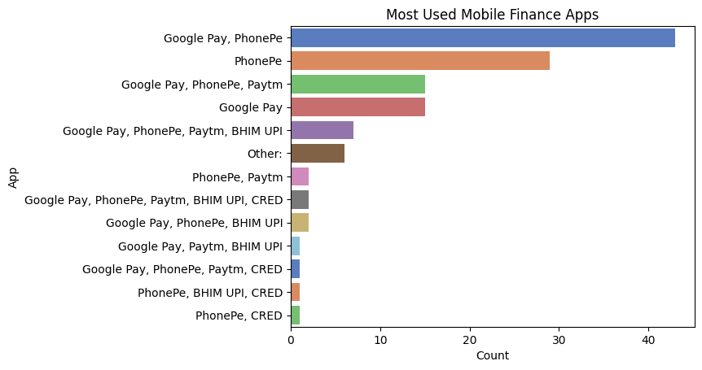
Figure 4.3: Most Frequently Used Mobile Finance Applications
Figure 4.4 represents the frequency of app usage. A majority of respondents used these apps either daily or weekly, indicating high dependency on digital finance tools for transactions, savings, and bill payments.
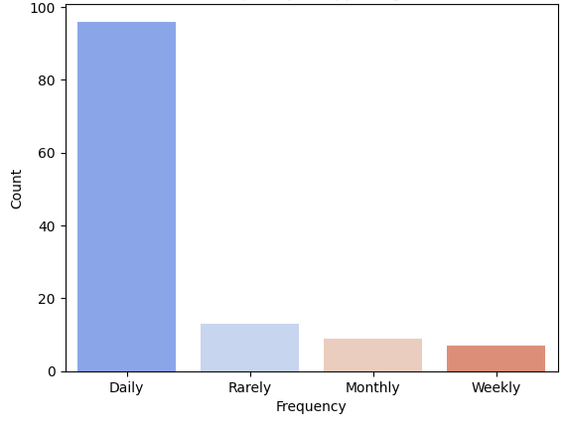
Figure 4.4: Frequency of App Usage among Respondents
This suggests that while users actively engage with mobile finance tools, the majority still rely on them for basic payment and expense tracking, rather than advanced investment or advisory functions.
3. Impact of Mobile Finance Applications
The impact of mobile finance apps was analyzed on budgeting, saving, investment, and financial literacy.
As presented in Figure 4.5, a large portion of respondents agreed that these apps helped them track expenses and save money efficiently.
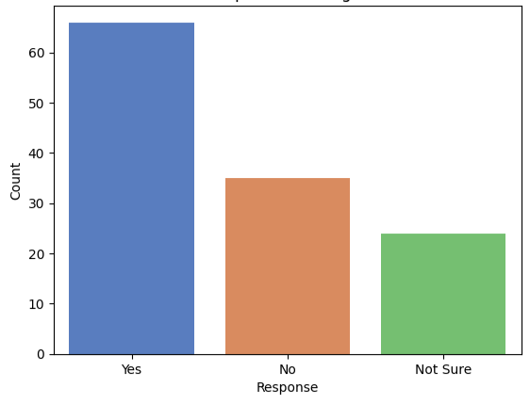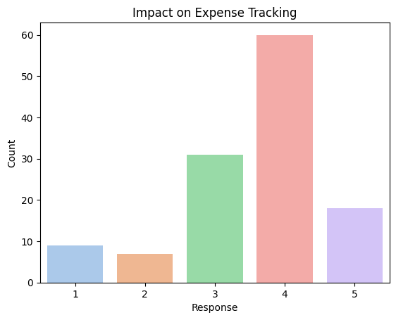
Figure 4.5: Impact of Mobile Finance Applications on Expense Tracking and Savings
Users reported that features such as expense categorization, transaction history, and budget alerts encouraged better spending control. However, only a smaller segment relied on these apps for investment decisions, as shown in Figure 4.6, indicating a moderate influence on investment-related activities.
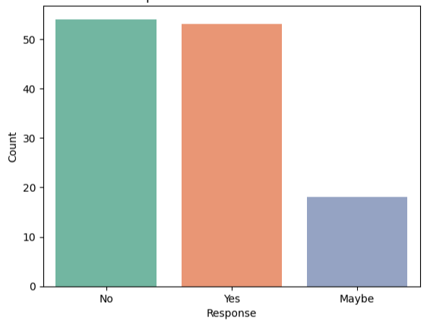
Figure 4.6: Influence of Mobile Finance Apps on Investment Decisions

4. Hypothesis Testing
To validate the research objectives, Chi-square tests of independence were conducted between key variables such as expense tracking, savings, and financial literacy. A significance level of p < 0.05 was used.
- Budgeting Habits (Q9 vs Q10): The chi-square value was 15.39 with a p-value of 0.052. Since p > 0.05, the relationship is not statistically significant at the 5% level, but it shows a borderline association. This indicates that while expense tracking is linked to savings behavior, the evidence is not strong enough to confirm a significant relationship.
- Investment Decisions (Q11): The survey results revealed that 43.2% of respondents do not rely on finance apps for investment decisions, while 42.4% do, and 14.4% sometimes do. This suggests that investment influence is present but not dominant, highlighting the limited role of finance apps in guiding investment activities.
- Financial Literacy (Q12 vs Q13): The chi-square value was 33.47 with a p-value of 0.0000085 (< 0.05), indicating a strong and significant relationship. This confirms that users who received financial advice from apps also found it useful and personalized, proving that mobile finance apps significantly contribute to financial literacy.
Aspect |  |  | Result | Interpretation
  χ² Value
  p-value
 | 15.39 | 0.052 | Not Significant | Expense tracking shows a weak but observable link with saving habits.
  Budgeting
  (Q9 vs Q10)
Investment Decisions | — | — |  | 43.2% of users do not rely on finance apps for investments; 42.4% do.
  Mixed influence
Financial Literacy | 33.47 | 0.0000085 | Significant | App-based financial advice significantly improves literacy and awareness.
Table 1 : Results of Chi- Square tests
Overall, the null hypothesis (H₀) is rejected. The findings support the alternative hypothesis (H₁), showing that mobile finance applications significantly enhance financial literacy and somewhat improve budgeting, while their impact on investment decisions is weaker but still relevant.
- Summary of Findings
- The majority of app users belong to the 18–35 age group, mainly students and professionals.
- Google Pay, PhonePe, and Paytm are the most frequently used applications.
- Mobile finance apps significantly improve financial literacy and budgeting discipline.
- The impact on investment decisions is limited, showing a need for improved advisory features.
- Python-based visual analysis provided clear data interpretation and statistical validation of hypotheses.
Discussion
The findings of this study provide important insights into the role of mobile finance applications in influencing financial behaviour. The results show that these applications are widely adopted among young and educated users, with the majority using them for payments, expense tracking, and savings. This highlights the growing integration of mobile financial tools into daily financial practices.

The hypothesis testing results reveal that mobile finance applications have a significant impact on financial literacy, as indicated by the strong relationship between receiving financial advice from apps and finding it useful. This confirms that apps are not only transactional tools but also serve as educational platforms that enhance users’ understanding of financial concepts.

However, the influence of mobile finance applications on budgeting habits was weaker, with results showing a borderline level of statistical significance. This suggests that while apps assist users in tracking expenses, other external factors such as personal discipline and financial goals may also affect savings behaviour.

The results related to investment decisions further emphasize this limitation. Although a considerable number of respondents acknowledged making investment-related decisions using finance apps, many still did not fully rely on them. This indicates that while these apps contribute to investment awareness, users continue to depend on traditional sources such as financial advisors, family, or personal research before making final decisions.

Overall, the discussion highlights that mobile finance applications have become an essential tool for improving financial literacy and promoting better money management practices. However, their role in shaping investment behavior remains limited, suggesting the need for further development of app-based financial advisory features.

4.2 Implications
The implications of this study provide valuable insights for fintech developers, financial institutions, policymakers, and users. The results not only highlight the current role of mobile finance applications but also suggest how they can be improved for greater financial inclusion, literacy, and user trust.

1. Practical Implications
The findings have strong real-world applications:
- For Developers :
The study suggests that mobile finance app developers should enhance educational and advisory features within applications. Personalized dashboards, AI-based financial suggestions, and goal-oriented budgeting can make these apps more interactive and effective in guiding users toward better financial decisions.
- For Financial Institutions:
Banks and fintech companies can collaborate to offer secure and intelligent finance platforms that combine digital payments, savings plans, and investment insights. These results show that mobile finance apps can help improve customer engagement and encourage better saving habits.
- For Users:
Regular usage of finance apps can strengthen financial discipline. Users can learn to monitor expenses, set realistic savings goals, and build stronger awareness about financial management.

2. Theoretical Implications
This study reinforces the Financial Literacy Theory, which states that improved financial knowledge leads to more responsible money management.
The results demonstrate that mobile finance applications are not just transactional tools but also act as digital learning environments that help users understand their financial behavior.
The integration of AI and data analytics in these apps shows how technology is reshaping personal finance management by providing real-time insights and automated advice.
3. Policy Implications
The outcomes of this research can guide government agencies and financial regulators in shaping effective fintech policies:
- Promote digital financial literacy programs that educate users on responsible app usage and data protection.
- Implement stricter data privacy and cybersecurity regulations to ensure user safety.
- Encourage innovation in the fintech sector to extend mobile financial services to rural and semi-urban populations.
By addressing these policy aspects, mobile finance applications can become a powerful tool for financial inclusion and economic empowerment in India.
Overall, the implications derived from the findings show that mobile finance applications have immense potential to enhance financial literacy, savings behavior, and user engagement.
However, developers and policymakers must focus on improving AI accuracy, data security, and educational content to ensure these applications serve as effective tools for sustainable financial growth.

CHAPTER 5 – CONCLUSION

5. Conclusion
This study explored the impact of mobile finance applications on financial literacy, budgeting, and investment decisions. Based on the responses of 124 participants, it was found that these applications play a significant role in improving financial literacy and promoting better financial awareness. Most respondents reported that apps helped them in tracking expenses and saving money, showing their usefulness in day-to-day financial management.
The findings also revealed that while finance apps contribute positively to budgeting habits, the statistical evidence was not very strong, indicating that personal financial discipline remains a key factor. Similarly, the role of finance apps in investment decisions was less dominant, as many users continue to rely on traditional methods or personal judgment before making investment choices.
Overall, the study concludes that mobile finance applications are effective tools for enhancing financial literacy and basic money management, though their potential in guiding investment decisions is yet to be fully realized.
In conclusion, the research confirms that mobile finance applications have revolutionized personal financial management by making it simpler, faster, and more data-driven. These tools contribute significantly to financial literacy and savings behavior, empowering users to take better control of their money. However, the study also recognizes that technology alone cannot replace human judgment in complex financial decisions such as investments.
Therefore, for future advancement, developers, educators, and policymakers should collaborate to enhance AI accuracy, user education, and cybersecurity within mobile finance platforms.
With continued innovation, these applications can play a transformative role in achieving financial inclusion and economic empowerment in the digital era.

5.1 Summary
This study focused on understanding the impact of mobile finance applications on users’ financial literacy, budgeting, saving, and investment behavior. A total of 124 valid responses were collected and analyzed using Python libraries such as Pandas, Seaborn, Matplotlib, and SciPy. Both descriptive and inferential statistics were used, including Chi-square tests of independence, to evaluate the relationships among various financial behavior factors.
The results revealed that mobile finance applications such as Google Pay, PhonePe, and Paytm are widely adopted among young and educated individuals for daily transactions, bill payments, and expense tracking. These apps have significantly contributed to enhancing financial literacy and awareness, enabling users to track expenses, set budgets, and develop saving habits.
However, the findings also indicated that while mobile finance apps help users maintain better control over their spending, their impact on budgeting habits was moderate. This suggests that personal discipline, motivation, and financial goals still influence saving behavior more than technology alone.
Similarly, the influence on investment decisions was found to be limited. Although users receive financial information through these apps, they still rely on traditional methods such as consulting family members, financial advisors, or personal research before investing.
Overall, the study concludes that mobile finance applications are effective tools for improving financial literacy and basic money management, making financial activities more convenient and organized. However, there remains significant potential to strengthen these apps’ roles in investment planning, personalized advice, and secure financial decision-making.

5.2 Future Work
While this research offers valuable insights, it also highlights several areas for improvement and further exploration:
- Larger and More Diverse Sample:
The current study included 124 respondents, which may not fully represent all categories of mobile finance app users. Future studies can include a larger and more diverse population across different regions, age groups, and income levels to enhance generalizability.
- Exploration of Specialized Applications:
The study primarily examined commonly used apps like Google Pay, PhonePe, and Paytm. Future research can focus on specialized financial management apps such as Mint, YNAB, or Groww to understand their advanced budgeting and investment impact.
- Use of Advanced Analytical Techniques:
Future researchers can apply advanced statistical or machine learning models to identify deeper
patterns in user behavior and financial decision-making accuracy, offering more predictive insights.
- Integration of AI and Data Security:
As Artificial Intelligence becomes more integrated into fintech, future work can explore how AI-driven recommendations, automated budgeting, and enhanced data security influence users’ trust and adoption of these apps.
- Behavioral and Educational Aspects:
Further studies can assess how long-term use of mobile finance apps affects users’ financial discipline, knowledge retention, and decision-making confidence over time.

CHAPTER 6 – REFERENCES

6. References
- Deloitte (2022). Mobile finance applications and their role in financial management. Deloitte Insights. Retrieved from https://www2.deloitte.com
- Kapoor & Singh (2020). Evolution of financial management: From manual bookkeeping to AI-driven finance apps. International Journal of Financial Studies, 8(3), 45–60.
- Brown et al. (2021). AI and machine learning in financial technology: Enhancing personal finance management. Journal of FinTech Innovations, 12(4), 78–95.
- Johnson et al. (2019). The behavioral impact of budgeting applications on spending habits. Journal of Personal Finance, 10(1), 34–50.
- Brown & Peterson (2020). Encouraging savings through automation: A study on Acorns and Qapital apps. Journal of Behavioral Economics, 11(3), 55–72.
- Lee & Kim (2022). Mobile investment applications: Lowering barriers to financial markets for retail investors. FinTech Advances, 15(2), 90–110.
- Johnson et al. (2019). The role of financial education and credit score monitoring in financial apps. Journal of Financial Literacy, 7(3), 88–105.
- Smith & Waller (2021). Enhancing financial literacy through fintech applications: A behavioral approach. Journal of Digital Finance, 9(2), 75–89.
- Gartner (2023). Consumer concerns over financial app security and data privacy. Gartner Research Report. Retrieved from https://www.gartner.com
- White & Chang (2021). Cybersecurity and risk management in financial technology applications. Deloitte Insights. Retrieved from https://www2.deloitte.com
- Smith & Waller (2022). The drawbacks of AI-driven financial decision-making: Passive habits and reduced awareness. Journal of Digital Banking, 10(1), 56–70.
- Lee, Park & Kim (2021). Limitations of AI-based financial planning: User challenges in automation-driven finance apps. AI & Financial Decision-Making Review, 13(4), 120–140.
- Brown et al. (2020). The effectiveness of AI-driven financial advice: A study on personalization and accuracy. Journal of FinTech Studies, 8(1), 112–130.
- Financial Literacy Theory (2020). The impact of financial knowledge on decision-making and financial behavior. The Journal of Financial Education, 5(2), 30–50.
- Nuresqi & Huda (2025). A review of mobile finance applications in personal finance management: Key features and usability. Jurnal Media Informatika. Retrieved from https://sisfokomtek.org
- Putra & Alqahtani (2025). Enhancing financial literacy in young adults: An Android-based personal finance management tool. Journal of Hypermedia & Financial Technology. Retrieved from https://edutech-journals.org
- Darwish (2025). Artificial intelligence implementation in education processes. Google Books. Retrieved from https://books.google.com
- Mohajer & Sadeghi (2025). Investigating the effect of using a home safety training application on accident risk management in the elderly. Experimental Technology Studies. Elsevier. Retrieved from https://www.sciencedirect.com
- Bahrini (2024). An HCI approach to privacy and security in mobile and ubiquitous applications. University of Bremen. Retrieved from https://media.suub.uni-bremen.de

- PwC Global FinTech Report (2023). The future of finance: Technology and digital innovation. Retrieved from https://www.pwc.com

- World Bank (2022). Digital financial inclusion and the role of fintech in developing economies. World Bank Publications. Retrieved from https://www.worldbank.org

- Accenture (2021). AI in finance: Driving smarter decisions and stronger customer engagement. Retrieved from https://www.accenture.com

- OECD (2023). Financial literacy and digital tools: Global insights and policy recommendations. OECD Publishing, Paris. Retrieved from https://www.oecd.org

- RBI (2024). Fintech and digital payment trends in India. Reserve Bank of India Bulletin. Retrieved from https://www.rbi.org.in

- McKinsey & Company (2023). The rise of digital finance apps and consumer behavior transformation. McKinsey Digital Report. Retrieved from https://www.mckinsey.com

CHAPTER 7 – APPENDICES

Appendix A – Python Code Used for Data Analysis
The following Python libraries and functions were used for data preprocessing, analysis, and visualization of survey results:
- Libraries Used: pandas, seaborn, matplotlib, scipy

- Purpose: To analyze relationships between expense tracking, savings behavior, and financial literacy.

- Tests Conducted: Chi-square test for independence (significance level p < 0.05).

# Step 1: Import necessary library
import pandas as pd

# Step 2: Upload the CSV file
from google.colab import files
uploaded = files.upload()

# Step 3: Load file into a DataFrame
df = pd.read_csv(list(uploaded.keys())[0])

# Step 4: Show first 5 rows
df.head()

# Step 2: Demographics Analysis
import seaborn as sns
import matplotlib.pyplot as plt

# Age Distribution
sns.histplot(df['1. What is your age? '], bins=10, kde=True, color="skyblue")
plt.title("Age Distribution of Respondents")
plt.xlabel("Age")
plt.ylabel("Count")
plt.show()

# Gender Distribution
sns.countplot(x="2. Gender", data=df, palette="pastel")
plt.title("Gender Distribution of Respondents")
plt.xlabel("Gender")
plt.ylabel("Count")
plt.show()

# Occupation
sns.countplot(y="3. What is your occupation? ",
data=df,
order=df["3. What is your occupation? "].value_counts().index,
palette="muted")
plt.title("Occupation of Respondents")
plt.xlabel("Count")
plt.ylabel("Occupation")
plt.show()

# Education level
sns.countplot(y="4. Education level ",
data=df,
order=df["4. Education level "].value_counts().index,
palette="Set2")
plt.title("Education Level of Respondents")
plt.xlabel("Count")
plt.ylabel("Education Level")
plt.show()

# Monthly Income Range
sns.countplot(y="5. Monthly Income Range ",
data=df,
order=df["5. Monthly Income Range "].value_counts().index,
palette="coolwarm")
plt.title("Monthly Income Range of Respondents")
plt.xlabel("Count")
plt.ylabel("Income Range")
plt.show()

# Step 3: Usage Analysis (App Usage Behavior)
# 1. Do you currently use finance apps? (Q6)
sns.countplot(x="6. Do you currently use any mobile finance applications?",
data=df, palette="Set2")
plt.title("Respondents Using Finance Apps")
plt.xlabel("Response")
plt.ylabel("Count")
plt.show()

# 2. Which apps are most used? (Q7)
sns.countplot(y="7. Which of the following apps do you use? ",
data=df,
order=df["7. Which of the following apps do you use? "].value_counts().index,
palette="muted")
plt.title("Most Used Mobile Finance Apps")
plt.xlabel("Count")
plt.ylabel("App")
plt.show()

# 3. How often do respondents use apps? (Q8)
sns.countplot(x="8. How often do you use these apps? ",
data=df,
order=df["8. How often do you use these apps? "].value_counts().index,
palette="coolwarm")
plt.title("Frequency of App Usage")
plt.xlabel("Frequency")
plt.ylabel("Count")
plt.show()

# Step 4: Impact Analysis (Effect of Apps on Financial Behavior)
# 1. Expense Tracking (Q9)
sns.countplot(x="9. Have these apps helped you track expenses better? ",
data=df, palette="pastel")
plt.title("Impact on Expense Tracking")
plt.xlabel("Response")
plt.ylabel("Count")
plt.show()

# 2. Saving Money (Q10)
sns.countplot(x="10. Do you save more money since using the app(s)? ",
data=df, palette="muted")
plt.title("Impact on Savings")
plt.xlabel("Response")
plt.ylabel("Count")
plt.show()

# 3. Investment Decisions (Q11)
sns.countplot(x="11. Do you make investment decisions based on these apps? ",
data=df, palette="Set2")
plt.title("Impact on Investment Decisions")
plt.xlabel("Response")
plt.ylabel("Count")
plt.show()

# 4. Financial Advice Received (Q12)
sns.countplot(x="12. Have you received financial advice or tips from the app? ",
data=df, palette="coolwarm")
plt.title("Financial Advice from Apps")
plt.xlabel("Response")
plt.ylabel("Count")
plt.show()

# 5. Usefulness of Advice (Q13)
sns.countplot(x="13. Was the advice useful and personalized to your goals?",
data=df, palette="Set1")
plt.title("Usefulness of Financial Advice")
plt.xlabel("Response")
plt.ylabel("Count")
plt.show()

# Step 5: Trust & Security Analysis
# 1. Trust in Recommendations (Q20)
sns.countplot(x="20. Do you trust the financial recommendations made by the app? ",
data=df, palette="Set2")
plt.title("Trust in App Recommendations")
plt.xlabel("Response")
plt.ylabel("Count")
plt.show()

# 2. Security Perception (Q21)
sns.countplot(x="21. How secure do you feel using finance apps?",
data=df, palette="muted")
plt.title("Perceived Security of Finance Apps")
plt.xlabel("Response")
plt.ylabel("Count")
plt.show()

# 3. Reading Permissions/Policies (Q22)
sns.countplot(x="22. Do you read app permissions or privacy policies before installing finance apps?",
data=df, palette="coolwarm")
plt.title("Reading App Permissions & Privacy Policies")
plt.xlabel("Response")
plt.ylabel("Count")
plt.show()

# 4. Security Issues Experienced (Q23)
sns.countplot(x="23. Have you ever experienced a security issue with a finance app? ",
data=df, palette="pastel")
plt.title("Security Issues Experienced by Users")
plt.xlabel("Response")
plt.ylabel("Count")
plt.show()

# Step 6: Hypothesis Testing
# Step 1: Budgeting habits (Q9 vs Q10)
from scipy.stats import chi2_contingency
import pandas as pd

ct_budget = pd.crosstab(df['9. Have these apps helped you track expenses better? '],
df['10. Do you save more money since using the app(s)? '])

chi2, p, dof, expected = chi2_contingency(ct_budget)
print("Chi-square Value (Budgeting):", chi2)
print("p-value:", p)

# Step 2: Investment decisions (Q11)
df['11. Do you make investment decisions based on these apps? '].value_counts(normalize=True) * 100

# Step 3: Financial Literacy (Q12 vs Q13)
ct_literacy = pd.crosstab(df['12. Have you received financial advice or tips from the app? '],
df['13. Was the advice useful and personalized to your goals?'])

chi2, p, dof, expected = chi2_contingency(ct_literacy)
print("Chi-square Value (Financial Literacy):", chi2)
print("p-value:", p)

Appendix B – Visual Representations
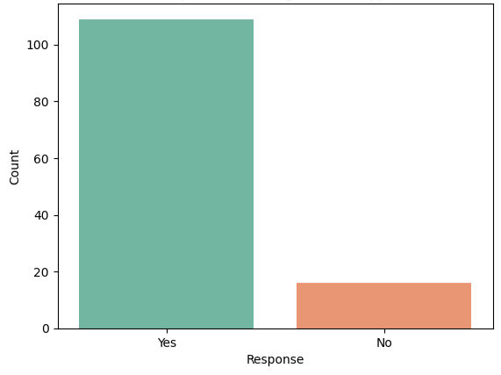
Fig.1 - Respondents using finance apps

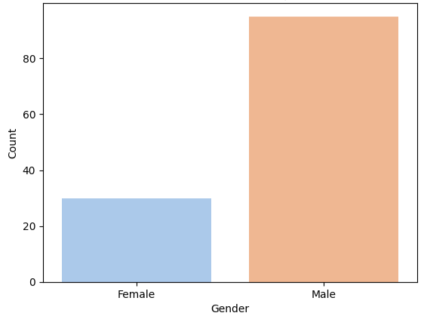
Fig.2 - Gender Distribution of Respondents
Fig.3 - Age Distribution of Respondents
Fig.4 - Occupation-wise Distribution of Respondents
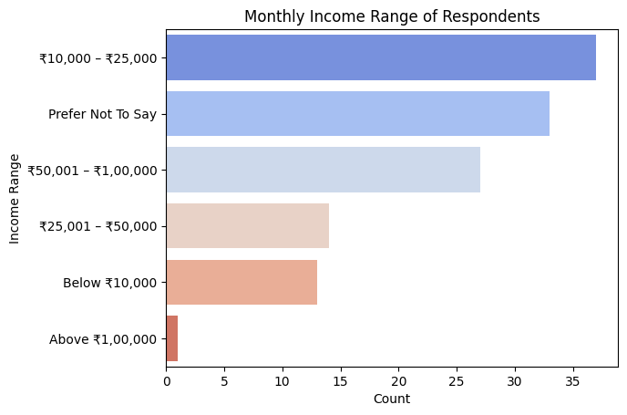
Fig. 5 - Monthly Income Range

Fig.6 – Most Used Mobile Finance Apps
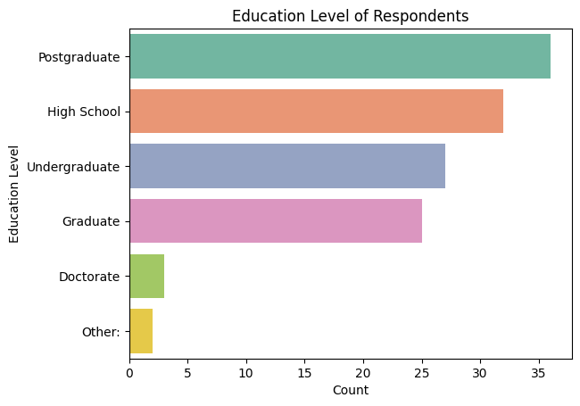
Fig. 7 - Education Level of Respondents
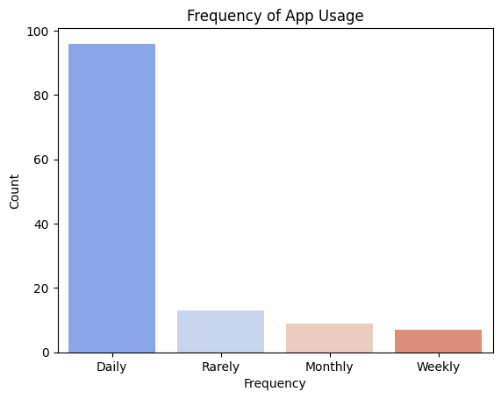
Fig. 8 – Frequency of App Usage
Fig.9 – Impact on Expense Tracking
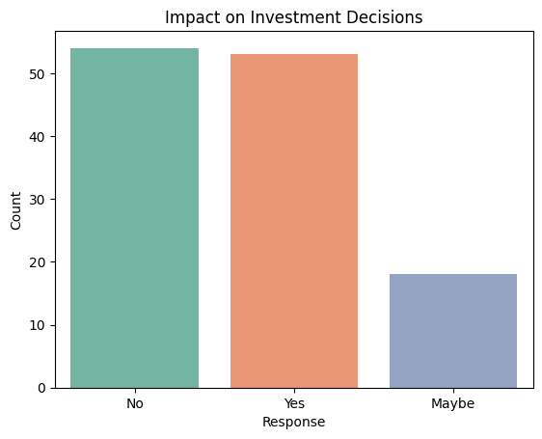
Fig. 10 – Impact on Investment Decisions
Fig.11 – Impact on Savings
Fig. 12 - Influence of Mobile Finance Apps on Investment Decisions
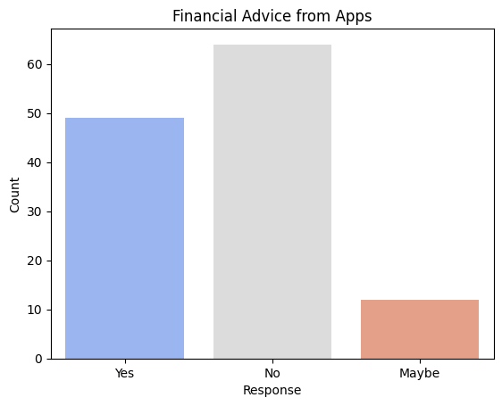
Fig. 13 – Financial Advice from Apps
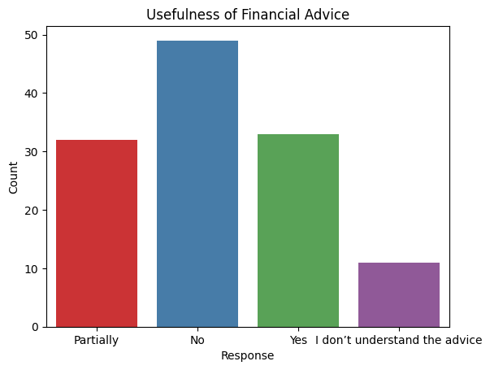
Fig.14 – Usefulness of Financial Advice
Appendix C – Survey Questionnaire
The following questionnaire was prepared using Google Forms to collect primary data for the research titled “A Study on Mobile Applications in Personal Finance Management.” It consists of 32 structured questions covering demographic details, app usage, behavioral impact, trust, and security perceptions.

- Google Form Link:
https://forms.gle/K9F1jpy8wprNcX7Q7

Section A – Demographic Details
- What is your age?
- Gender
- What is your occupation?
- Education level
- Monthly Income Range

Section B – Usage of Mobile Finance Applications
- Do you currently use any mobile finance applications?
- Which of the following apps do you use?
- How often do you use these apps?
- Have these apps helped you track expenses better?
- Do you save more money since using the app(s)?
- Do you make investment decisions based on these apps?

Section C – Financial Literacy and App Features
- Have you received financial advice or tips from the app?
- Was the advice useful and personalized to your goals?
- Do you understand how the app gives recommendations?
- Which features do you regularly use?
- Which of these features do you find most helpful in finance apps?
- What motivates you to continue using a particular finance app?
- What do you mainly use finance apps for?
- Have you ever taken financial action (like saving, investing, or budgeting) because of advice from the app?

Section D – Trust and Security
- Do you trust the financial recommendations made by the app?
- How secure do you feel using finance apps?
- Do you read app permissions or privacy policies before installing finance apps?
- Have you ever experienced a security issue with a finance app?
- What challenges have you faced using finance apps?
- Do you think these apps should offer more content on financial education?

Section E – Accessibility and Future Enhancements
- What language do you prefer while using finance apps?
- Are current finance apps suitable for rural and regional users?
- What would make you use these apps more frequently?
- Would you recommend mobile finance apps to others?
- What features or improvements would you like to see in future apps?
- Where are you from?
- Do your family members use mobile finance apps?
.

Appendix D – Summary of Hypothesis Testing
This appendix presents the results of the Chi-square test of independence conducted to determine the relationships between key variables such as budgeting, investment decisions, and financial literacy. The test was performed using Python’s scipy.stats library at a significance level of 0.05 (p < 0.05).

Aspect |  |  | Result | Interpretation
  χ² Value
  p-value
 | 15.39 | 0.052 | Not Significant | Expense tracking shows a weak but observable link with saving habits.
  Budgeting
  (Q9 vs Q10)
Investment Decisions | — | — |  | 43.2% of users do not rely on finance apps for investments; 42.4% do.
  Mixed influence
Financial Literacy | 33.47 | 0.0000085 | Significant | App-based financial advice significantly improves literacy and awareness.
Table 2 : Results of Chi-Square Tests

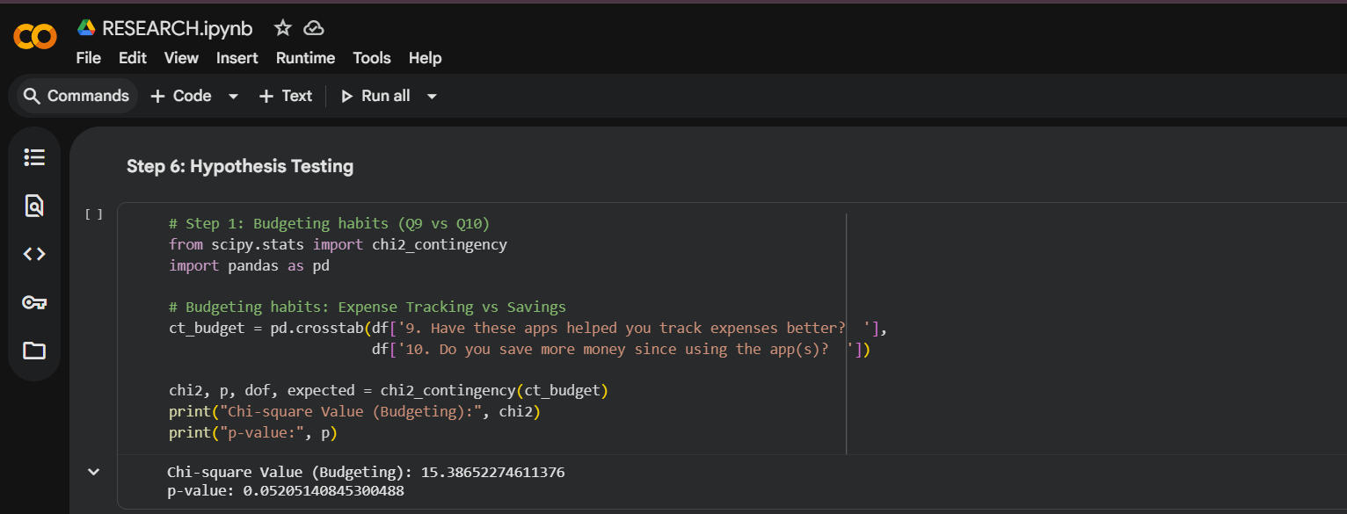
Figure 15.Hypothesis Testing Result

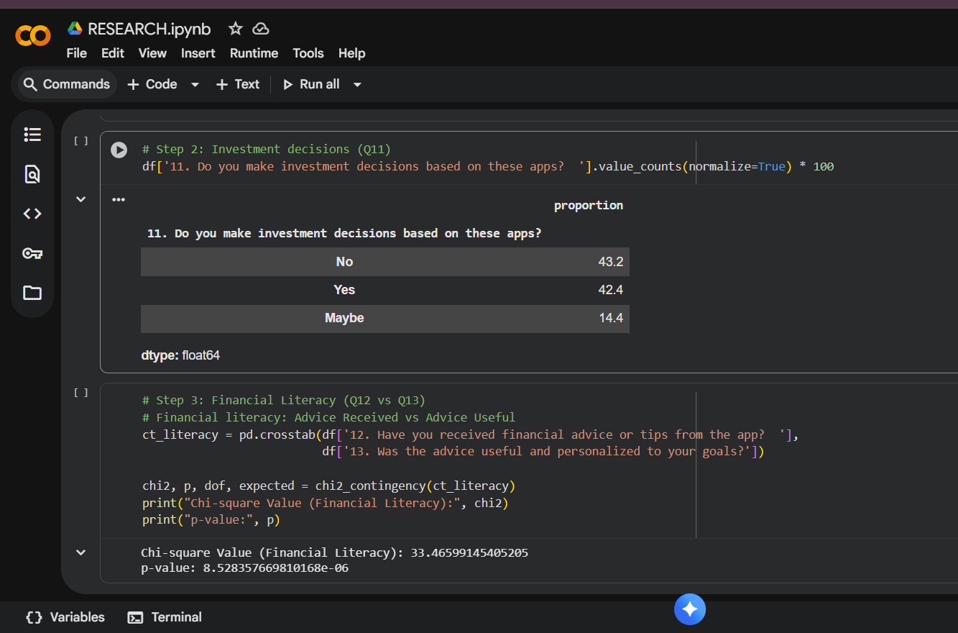
Figure 16: Chi-Square value and p-value Result

Software and Libraries Used
- Platform: Python 3 (Google Colab)
- Libraries: pandas, scipy, seaborn, matplotlib

Conclusion
The hypothesis tests indicate that mobile finance applications significantly improve financial literacy, partially influence budgeting habits, and have a limited effect on investment decisions.
Overall, they serve as effective tools for promoting better money-management behavior among users.

CHAPTER 8 – ANNEXURE
PROGRESS SHEET

Progress Sheet
Review Phase | Date | Tasks | Remarks
Review 1 | 18/072025 | 1. Problem statement finalization  2. Introduction  3. Objectives & scope  4. Literature review  5. Proposed methodology  6. Identification of tools & dataset sources | Initial project setup and conceptual framework review
Review 2 | 20/08/2025 | 1. Questionnaire design  2. Data collection  3. Data cleaning & preparation  4. Data analysis  5. Interpretation of results  6. Charts & visual findings | Evaluation of data collection and analysis work
Review 3 | 14/11/2025 | 1. Final documentation of research project  2. Results, evaluation & conclusion  3. Final report formatting  4. Plagiarism report  5. PPT preparation for viva | Final evaluation and readiness

